EAS506
HW4
Matthew Sah

1.
For this question, i finished my code work in R considering that R has an more extensive and better integrated library than the existing options in Python.
Although there are a few less well known libraries for subset selection(best, forward , backward), the libraries in python would require manual integration of subset selections and calculation of AIC and BIC values.

I’ve received a lowest of 0.4181619 for AIC, 6.040028 for BIC; 0.2926718 for 5-fold cross validation and 0.1788826 on 10-fold validation, and 0.2137558 for the bootstrap method of prediction errors. For all the methods, the minimal value was found on the 3rd object, whereas on BIC and 5-fold CV were found on the first and sixth respectively.
As we further examince AIC and BIC; we find that AIC and BIC used the same number of variables however gained different results when using different methods. For BIC, it received the best results when using additional variables “gleason”, “ppg45” in relative to AIC.

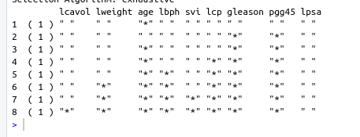
2.
After implementing the original data into a decision tree and graphing it, we can see that first and foremost we’re using the 11th variable to make the first decision, after investigating we ca see that te 11th variable is “Hue”, therefore implying that its possible to tell the difference between the type of wine by the color, being the first factor to be chosen, we can identify that it mostlikely has highest priority. Following are the “ASH” and “OD280/OD315 of diluted wins” could be used to tell the three wines from the rest.

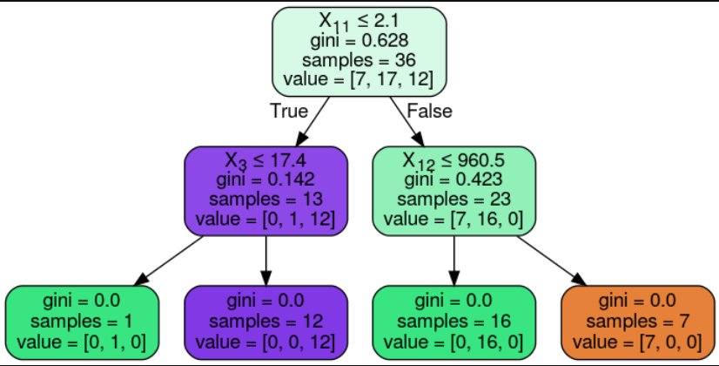
3.
For the selected data, i used the “Weekly” data from the R datasets. It’s main content is regarding weekly percentage returns for the S&P 500 stock index between 1990 and 2010 with it’s target column an binary output, either with stock prices going up or going down. Cleaning the data and testing with different predictors, i concluded that the “Year ” column had little effect on the whole result. The “Lagi” columns had more impact than the other predictors included, with i being the number of weeks past and “LagI” the percentage of return from the past i weeks.
Testing out the data with bagging, boosting, and random forest all yielded an 100% accuracy, which i presume was due to the smaller data set and lack of additional predictors to make the prediction more complex. With the non-ensemble methods, KNN returned an accuracy of 0.88 whereas the logistic regression returned a higher accuracy of 0.99. I deduce this is because of the characteristics of ensemble methods where they can deal with more complex models that are not just linear in comparison to non-ensemble models.

Although my results do not have a distinct difference to the committee machines, committee machines are mainly better than other data sets in two aspects; The first reason is better test set performance and the second is reduced computational complexity.

4.
My tests were all tested under 1000 n_estimators (trees),i have also tried other number of trees in my testing functions, however it was under 1000 trees that my OOB and accuracy received the optimal accuracy( or test error). According to the plot produced from Python using the matlabplt library, it shows that the test accuracy doesn’t change once it reaches a certain level of M values, which is controlled by the max_feature variable inside the RandomForestClassifier function.

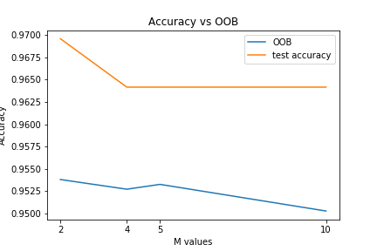
5.
A random forest is a data construct applied to machine learning that develops large numbers of random decision trees analyzing sets of variables.
The Random Forest has it’s name because each tree in the forest is built by randomly selecting a sample of the data.

